NEWSPIRACY—TRAINING TEACHERS IN POST TRUTH RECOGNITION

Mariano Sanz-Prieto

Elena López-de-Arana

Gema de-Pablo-González

*Universidad Autónoma de Madrid*

SPAIN

# Abstract

The pervasiveness of information overload, or "infoxication", renders us increasingly susceptible to fake news and its uncritical acceptance. This phenomenon, characterized by deliberate disinformation, has found fertile ground in the political sphere. Consequently, fostering critical thinking and proper education in our students is crucial for solidifying our democracy on robust foundations.

Newspiracy emerges as a project offering valuable tools and training to empower educators in addressing these issues with their students. This initiative seeks to equip them with the necessary skills to navigate the complex landscape of information and discern genuine news from fabricated narratives. By nurturing critical thinking and media literacy, we can empower individuals to make informed decisions, combat misinformation, and ultimately safeguard the integrity of our democratic processes.

# Introduction

In contemporary society, we navigate a digital landscape saturated with various channels for creating, sending, accessing, and receiving information. These include traditional media outlets, their online platforms, social networks, instant messaging applications, and email, among others. While this diversity facilitates access to a wealth of information, it also poses the risk of information overload, commonly referred to as "information intoxication" (infoxication), a concept already discussed in the 1990s (Arribas & Sanz-Prieto, 1996). The phenomenon has since become more "professionalized". Essentially, infoxication consists of an overload of information that exceeds an individual's processing capacity. In our current context, this information often reaches us passively via social networks and instant messaging, without us always having control over it. This scenario presents a new challenge: discerning between valuable, biased, or false information, which complicates its processing into useful knowledge. Responsible management of this information overload has thus become a critical skill in the digital era.

The term "fake news" refers to lies, hoaxes, misleading or false news (Martín-Herera & Micaletto-Belda, 2021). In essence, it involves the intentional dissemination of false or misleading information to manipulate public opinion or create confusion. However, for our specific analysis, we will primarily utilize the definition provided by Baptista et al. (2021), which characterizes fake news as an article that fabricates a report or real news in the online domain, mimicking its format to appear legitimate and credible to the public.

This phenomenon is not new but has seen a significant surge with the expansion of digital technologies, particularly social networks and instant messaging applications. The speed at which fake news spreads is exponentially greater than that of verified information. This rise in disinformation results in widespread uncertainty regarding the information available online, making it one of the most pressing and concerning issues today (Alonso García et al., 2020). Additionally, the influence power of fake news is substantial, due to its capacity to generate intense emotions and appeal to cognitive biases. It can have negative impacts in various spheres, especially in the political and social realms, where it can sway public opinion, manipulate electoral processes, and promote hate and discrimination. Most alarmingly, it can erode trust in institutions.

# Post-truth Society

Has truth ever existed, or does it exist today? Generally, our perspective will limit what we can perceive or believe. Morin (1999) asserted that knowledge is not a reflection of reality but a translation or interpretation we make, where language and thought mediate, as well as subjectivity and affectivity. It is naïve to think that rationality dominates emotion. The term "post-truth" refers to the phenomenon where, in today's digital society, objective facts are less significant or effective in shaping public opinion. In many cases, opinions are given the same value, and appeals to emotion or personal beliefs—whether false or not—end up holding the same weight as objective facts or data. The era of post-truth signifies a shift in the credibility we grant to information. The necessity to substantiate what is said becomes blurred, and discourses are accepted or rejected based on how well they align with pre-existing mental schemas (Martín-Herera & Micaletto-Belda, 2021).

The culture of post-truth is often justified under the guise of freedom of expression. However, the reality is that it erodes democracy through the disinformation and propaganda to which citizens are subjected by fake news. It directly impacts the ability to access reliable and valid information. We must begin to consider how to resolve the conflict between two democratic rights: freedom of expression versus access to truthful information. To address this, we need to analyze the methods used to corrupt the system.

# Where Are We Now?

The reality is that social networks and the increasing digitalization of our lives have enhanced the public's ability to exercise the right to freedom of expression. This should ideally translate into greater opportunities to contrast opinions and enable the closest approximate to the truth to emerge. However, the reality is that fake news often produces the opposite effect, using freedom of expression to undermine the truth by slandering and increasing hostility and hatred towards socially vulnerable groups such as immigrants or the diversity of affective-sexual relationships. It also directly stigmatizes feminism, which means half of our population (Gómez de Ágreda, 2018).

**Figure 1**

*Threat with False Information in the World. Statista*

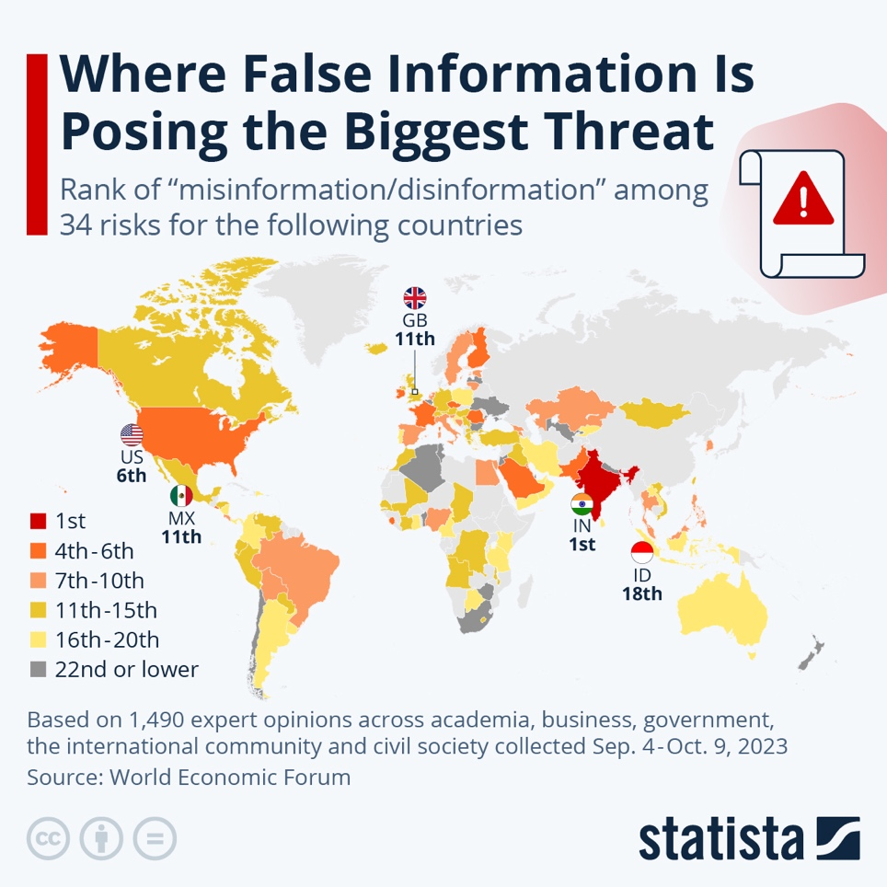

*Note*. From Fleck, 2024, https://www.statista.com/chart/31605/rank-of-misinformation-disinformation-among-selected-countries/

In the current digital era, information spreads at unprecedented speeds, and the same applies to fake news. These news pieces, characterized by deliberate disinformation circulated across various media, have found fertile ground in the political sphere (Baptista & Gradim, 2022). Certain political parties have utilized and continue to use them as a strategic tool to influence public opinion and advance their agendas (Igwebuike & Chimuanya, 2020). According to Baptista and Gradim (2020), this strategy not only manipulates the perception of facts but also has devastating consequences for already vulnerable groups such as women, the LGTBIQ+ community, and refugees or migrants.

We aim to explore how fake news created and propagated by far-right parties affects these oppressed groups and perpetuates inequality and discrimination in society. Recognizing such fake news as a society is crucial since, as noted by Lawson et al. (2023), fake news can foster political polarization, provoke division among groups, and encourage malicious behaviours.

In this context, far-right parties have found an opportunity to reinforce their ideological narratives and exacerbate polarization (Leyva & Beckett, 2020). By employing precise and targeted communication strategies, these political formations create and disseminate false content which, when shared massively, manage to sow informational chaos and confusion among the public (Peucker & Fisher, 2022). This confusion translates into widespread distrust of traditional media and democratic institutions, facilitating the advance of authoritarian and anti-democratic agendas (Lawson et al., 2023).

Women have historically been one of the groups most affected by fake news. They have been subjected to disinformation campaigns that trivialize or deny gender violence, promote harmful stereotypes, and obstruct efforts to achieve gender equality. Far-right parties often propagate narratives that reinforce traditional gender roles and undermine advancements in gender equality (Almenar et al., 2021). A clear example is the dissemination of false news that exaggerates cases of false gender violence accusations to discredit the feminist movement and policies protecting women (Sahadevan & Deepak, 2022). These news pieces not only undermine the credibility of gender violence victims but also foster a climate of distrust and hostility towards women who report abuse. They perpetuate the notion that advancements in women's rights threaten social stability, which can have a deterrent effect on the fight for gender equality (Geertsema-Sligh & Vos, 2022).

Refugees and migrants are another group that has suffered the consequences of fake news propagated by far-right parties. These news items often depict migrants as criminals, terrorists, or economic parasites burdening public resources and posing national security threats (Wright et al., 2020). This disinformation is used to justify restrictive immigration policies and draconian security measures (Boukala, 2021).

The widespread dissemination of these fake news creates an environment of xenophobia and racism that exacerbates the marginalization of migrants and refugees. They are denied access to basic opportunities and resources and are exposed to violence and harassment. Furthermore, this fake news can sway public opinion to support policies that violate the human rights of migrants and refugees (Amores et al., 2020).

The LGTBIQ+ community is also gravely affected by fake news propagated by far-right parties. These news stories often spread myths and falsehoods about LGTBIQ+ individuals, portraying them as a threat to morality and social order (Peucker & Fisher, 2022). Recurrent examples include the propagation of conspiracy theories linking the LGTBIQ+ community to child abuse or the so-called “gender ideology”' a fictitious construct purportedly aiming to impose a radical agenda on society (Leyva & Beckett, 2020). These examples of fake news not only reinforce existing prejudices and discrimination but also incite violence and hatred against LGTBIQ+ individuals. The demonization of this community in the media can legitimize aggressive behaviours and justify the denial of their fundamental rights. Ultimately, these false narratives hinder the fight for equality and the acceptance of sexual and gender diversity (Hinz et al., 2023).

Far-right parties effectively utilize social networks to spread fake news, and platforms such as Facebook, TikTok, X (formerly Twitter), and WhatsApp are powerful tools for disseminating false information due to their algorithms prioritizing emotionally charged content (Vziatysheva, 2020). These parties often collaborate with sympathetic media outlets and influential public figures to amplify their messages. The use of bots and trolls is also common, as they can generate an appearance of consensus and massive support for the false narratives (Dourado, 2023).

Fake news propagated by far-right parties affects society at large, not just vulnerable groups. When the populace cannot distinguish between truth and lies, the very foundations of democracy are undermined (Watts et al., 2021). It is crucial to note that young people are particularly vulnerable to the influence of fake news due to their higher exposure to social networks and instant messaging platforms.

In this context, initiatives like Newspiracy become relevant by offering tools and training to detect and combat fake news. The project aims to strengthen social resilience against manipulation and disinformation through the promotion of critical thinking and the development of skills to evaluate information. Specifically targeting future educators ensures that these skills are instilled in future generations from the school level.

# NEWSpiracy: Fighting the Online Post-truth Conspiracy

The Newspiracy project (European Commission, 2022) commenced in 2022 as a response to the information overload arising from new digital media and the advent of social networks, which have contributed to the rise of fake news. The objective of Newspiracy is to raise public awareness about the existence and influence of fake news, understanding its mechanisms and creation processes to enable better detection and deeper analysis.

Additionally, the project addresses topics related to the appropriate use of media, types of fake news, and potential solutions to this phenomenon, with a particular emphasis on the development of critical thinking as the primary driver of change.

NEWSpiracy's main goal is to develop critical thinking skills among university professors and students from various undergraduate and graduate programs, emphasizing that they must be critical of the information they receive, as they are the ones who will shape the society of the future. To develop critical thinking skills, the project focuses on fake news. To this end, an online training and an interactive environment have been developed to address these issues.

The specific objectives of this project are:

* To develop critical thinking about fake news among university students.
* To raise awareness of the realities faced by the most vulnerable sectors of society and the negative impact fake news has on them.
* To detect and analyze fake news.
* To explore possible solutions to the phenomenon of fake news.

The project began in November 2022 and is scheduled to conclude in October 2024, lasting a total of two years. The project consortium comprises five countries and six partners:

* Autonomous University of Madrid (Spain) - Coordinator
* University of the Aegean (Greece)
* Latvian University (Latvia)
* CARDET (Cyprus)
* PRO WORK (Netherlands)
* Fundación SIGLO22 (Spain)

The project's main outcomes are found in Work Packages 2 and 3: In-service training and Truth-track (a fake news detector and interactive environment).

## In-service Training

The in-service training is a learning package aimed at developing critical thinking and identifying fake news through various learning modules:

* + Disinformation: fake news and post-truth
  + The media: good use of social media
  + News items: writing structure
  + Critical thinking for active participation in society
  + Ways of acting against fake news

These learning modules have been developed in various formats to meet the accessibility needs of our diverse society. Firstly, a downloadable document has been created, accessible from the project platform and website. This document is designed as a "teacher's manual" and can be read virtually in Flipbook format or downloaded as a PDF (<https://newspiracy.eu/tutor-handbook/>).

Secondly, using instructional design, the learning modules have been made available on a Learning Management System (LMS) platform built with Moodle (<https://learning.newspiracy.eu/>). This platform is open and accessible to anyone interested. The modules are structured in a way that allows participants to test their knowledge through games, quizzes, and other types of activities.

Additionally, completion badges have been included. As participants complete the modules and their activities, they will earn badges certifying their participation. The platform and modules are accessible in all the languages of the project partners, which include Spanish, Greek, Dutch, and Latvian.

## Truth - Track

Truth-Track is an output in an interactive environment (<https://newspiracy.eu/truth-track/>) that allows participants to generate and comment on news items and posts. With various easy-to-use formats and functionalities, this space fosters transnational cooperation, enhances linguistic diversity, and promotes meaningful interactions between students and faculty. It operates like a social network: users create an account, publish content, and vote or comment on others' posts. The philosophy behind this interactive environment is to apply the knowledge acquired from the training plan of the previous output, learning to identify fake news based on its structure and content. Participants can choose different formats such as a newspaper article, an Instagram post, or a tweet.

**Figure 2**

*Four Truth-Track Interface Examples*

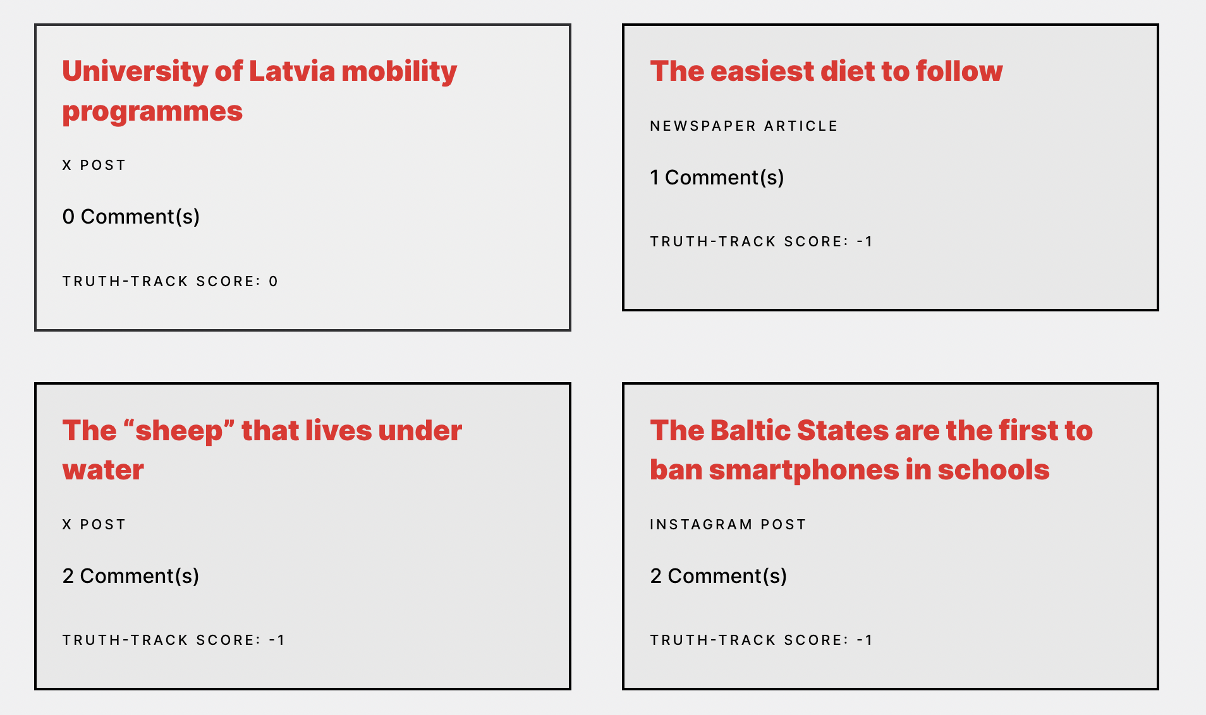

**Figure 3**

*Truth-Truck Interface Example including a Response Comment*

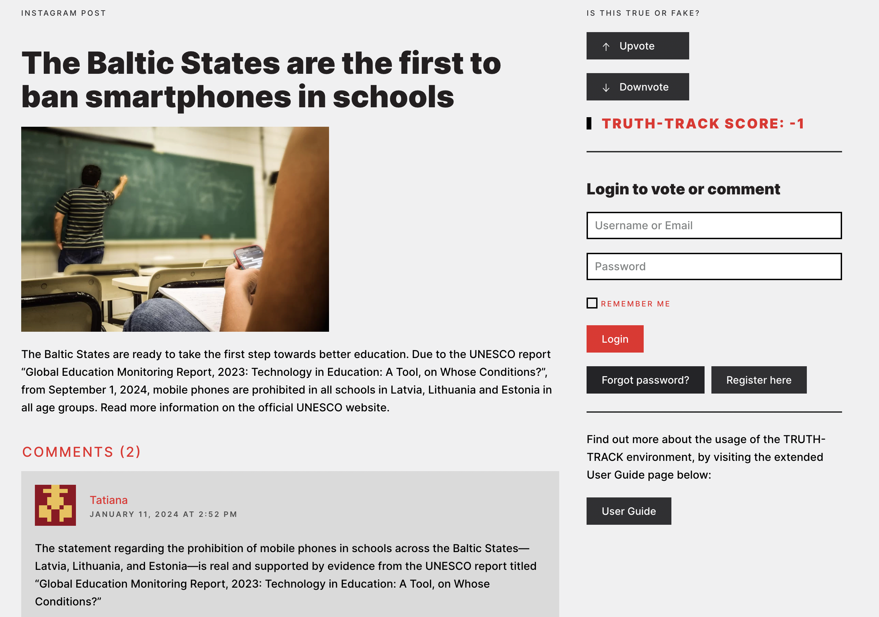

Interaction can occur in two ways: voting or commenting. Voting positively indicates that the user considers the post to be real news, while voting negatively indicates it is considered fake news. Each post displays a counter showing how many positive and negative votes it has received, thus revealing whether people believe the news is real or fake. Users can also add comments explaining their opinions.

The project's tools can be used diversely in classrooms, ranging from early childhood education to university levels, adapting specific activities to the age of the students. In some cases, students can directly use the project’s platforms, while in others, teachers can generate analysis and interpretation activities based on pre-generated content (López-de-Arana et al, 2024).

# Conclusions

Fake news has profound and varied effects on our daily lives, eroding trust in democratic institutions, fuelling political polarisation, and perpetuating discrimination and negative stereotypes towards vulnerable groups such as women, migrants, and the LGTBIQ+ community. Fake news hampers the ability of citizens to distinguish between truth and lies, a fundamental aspect of a healthy functioning democracy. Specifically the analysis of the relationship between the veracity of news and gender is not exhaustive but is consistent, firmly suggesting that gender should be an important consideration in critical studies and scientific research on fake news (Sahadevan & Deepak, 2022). Fake news represents a crucial challenge in the digital age. Addressing this issue requires a collective effort involving educational institutions, media outlets, digital platforms, and the citizenry itself.

Fake news perpetuates discrimination, fosters hatred, and undermines progress towards equality and social justice. Combating this threat requires a coordinated societal effort, including media and digital platforms, to protect the truth and promote a coexistence based on respect and inclusion. Only through education, transparency, and collective responsibility can we mitigate the damage caused by fake news and build a more just, informed, and resilient (digital) society against the threat of disinformation.

This is why it is essential to promote critical education from an early age. Projects such as Newspiracy play a crucial role in developing critical thinking skills among students and teachers. Raising awareness of the existence and impact of fake news, as well as teaching techniques for detecting and analysing fake news, are important steps in this direction. The use of interactive platforms and educational modules accessible in several languages also facilitates this learning.

We must encourage the abandonment of deterministic conceptualizations such as the absolute falsehood promoted by the culture of post-truth, and embrace the complexity of reality and the human condition, learning to "navigate in an ocean of uncertainties through archipelagos of certainty" (López-de-Arana et al., 2013; Morin, 1999, p. 43).

To curb the use of fake news by the far right, it is essential to improve transparency and accountability on social media platforms by developing algorithms that prioritise truthfulness over emotionally charged content. In addition, it is vital to foster international cooperation to regulate and sanction disinformation. Only through a coordinated and multifaceted effort can we reduce the negative impact of fake news and promote a fairer, more informed and cohesive society.

# References

Almenar, E., Aran-Ramspott, S., Suau, J., & Masip, P. (2021). Gender differences in tackling fake news: Different degrees of concern, but same problems. *Media and Communication, 9*(1), 229-238. <https://doi.org/10.17645/mac.v9i1.3523>

Alonso García, S., Gómez García, G., Sanz Prieto, M., Moreno Guerrero, A. J., & Rodríguez Jiménez, C. (2020). The impact of term fake news on the scientific community. Scientific performance and mapping in web of science. *Social Sciences, 9*(5), 73. doi: <https://doi.org/10.3390/socsci9050073>

Amores, J., Arcila-Calderón, C., & Blanco-Herrero, D. (2020). Evolution of negative visual frames of immigrants and refugees in the main media of Southern Europe. *El profesional de la información*. <https://doi.org/10.3145/epi.2020.nov.24>

Arribas, Y., & Sanz-Prieto, M. (1996). National Profiles: Spain. In *The Multimedia Yearbook 1996*. FPL.

Baptista, J., Correia, E., Gradim, A., & Piñeiro-Naval, V. (2021). The influence of political ideology on fake news belief: The Portuguese case. *Publications,* *9*(2), 23. <https://doi.org/10.3390/publications9020023>

Baptista, J., & Gradim, A. (2020). Online disinformation on Facebook: The spread of fake news during the Portuguese 2019 election. *Journal of Contemporary European Studies*, *30*(2), 297 - 312. <https://doi.org/10.1080/14782804.2020.1843415>.

Baptista, J., y Gradim, A. (2022). Who Believes in Fake News? Identification of Political (A)Symmetries. *Social Sciences*. <https://doi.org/10.3390/socsci11100460>

Boukala, S. (2021). Far-right discourse as legitimacy? Analysing political rhetoric on the “migration issue” in Greece. *Studies in Communication Sciences, 21*(2), 329-341. <https://doi.org/10.24434/j.scoms.2021.02.014>

Dourado, T. (2023). Who posts fake news? Authentic and inauthentic spreaders of fabricated news on Facebook and Twitter. *Journalism Practice*, *17*(10), 2103 - 2122. <https://doi.org/10.1080/17512786.2023.2176352>.

European Commission. (2022). *Newspiracy: Fighting the online post-truth conspiracy*. ERASMUS Project Number: 2022-1-ES01-KA220-HED-000089608. https://newspiracy.eu/

Fleck, A. (2024, January 19). Where False Information Is Posing the Biggest Threat [Digital image]. Retrieved June 17, 2024, from https://www.statista.com/chart/31605/rank-of-misinformation-disinformation-among-selected-countries/

Geertsema-Sligh, M., & Vos, T. (2022). Running up Against a Brick Wall: U.S. Metajournalistic Discourse of Gender Equality in Newsrooms. *Journalism Studies*, *23*, 1758 - 1778. <https://doi.org/10.1080/1461670X.2022.2112905>

Gómez de Ágreda, A. (2018). Falsas noticias, no noticias falsas. *Telos, 109*, 18-21. https://telos.fundaciontelefonica.com/wp-content/uploads/2018/10/telos-109-asuntos-de-comunicacion-angel-gomez-de-agreda.pdf

Hinz, T., Walzenbach, S., Laufer, J., & Weeber, F. (2023). Media coverage, fake news, and the diffusion of xenophobic violence: A fine-grained county-level analysis of the geographic and temporal patterns of arson attacks during the German refugee crisis 2015–2017. *PLOS ONE*, *18*(7). <https://doi.org/10.1371/journal.pone.0288645>

Igwebuike, E. E., & Chimuanya, L. (2020). Legitimating falsehood in social media: A discourse analysis of political fake news. *Discourse and Communication*, *15*(1), 42-58. <https://doi.org/10.1177/1750481320961659>

Lawson, M. A., Anand, S., & Kakkar, H. (2023). Tribalism and tribulations: The social costs of not sharing fake news. *Journal of Experimental Psychology: General, 152*(3), 611-631. <https://doi.org/10.1037/xge0001374>

Leyva, R., & Beckett, C. (2020). Testing and unpacking the effects of digital fake news: on presidential candidate evaluations and voter support. *AI & SOCIETY*, *35*, 969 - 980. <https://doi.org/10.1007/s00146-020-00980-6>

López-de-Arana, E., Rekondo, Z. & Salegi, E. (2013). Ziurgabeak diren testuinguruen erabilera Haur Hezkuntza Graduko ikasleen formazioan. *Ikastaria. 19*, 285-310.

López-de-Arana, E., Sanz-Prieto, M., & de Pablo González, G. (2024). Propuestas pedagógicas para ayudar a la infancia y adolescencia a descubrir la verdad sobre las fake news. In A. Neubauer (Ed.), *La educación intercultural en la sociedad digital: teoría y propuestas innovadoras* (pp. 81-97). Editorial Universitas, S.L.

Martín-Herrera, I., & Micaletto-Belda, J. P. (2021). Opiniones y actitudes de los estudiantes universitarios de Comunicación ante las fake news. Diagnóstico en un ecosistema docente. *Comunicación y Hombre, 17*, 193-206. doi: <https://doi.org/10.32466/eufv-cyh.2021.17.661.193-206>

Morín, E. (1999). *Descargar los 7 saberes necesarios para la educación del futuro*. United Nations Educational, Scientific, and Cultural Organization (UNESCO). <https://www.edgarmorinmultiversidad.org/index.php/descarga-libro-los-7-saberes.html>

Peucker, M., & Fisher, T. J. (2022). Mainstream media use for far-right mobilisation on the alt-tech online platform Gab. *Media, Culture & Society*, *45*(2), 354 - 372. <https://doi.org/10.1177/01634437221111943>.

Sahadevan, N., & Deepak, P. (2022). Gender bias in fake news: An analysis. *ArXiv*:2209.11984 [csCY]. <https://doi.org/10.48550/arXiv.2209.11984>

Vziatysheva, V. (2020). How fake news spreads online? *International Journal of Media and Information Literacy*. https://doi.org/10.13187/ijmil.2020.2.217.

Watts, D., Rothschild, D., & Mobius, M. (2021). *Measuring the news and its impact on democracy.*In D. A. Scheufele (Ed.), *Proceedings of the National Academy of Sciences 118*(15): *Advancing the Science and Practice of Science Communication: Misinformation about Science in the public sphere*. [*https://doi.org/10.1073/pnas.1912443118*](https://doi.org/10.1073/pnas.1912443118)*.*

Wright, C., Brinklow-Vaughn, R., Johannes, K., & Rodriguez, F. (2020). Media portrayals of immigration and refugees in hard and fake news and their impact on consumer attitudes. *Howard Journal of Communications*, *32*(4), 331 - 351. <https://doi.org/10.1080/10646175.2020.1810180>.

# Author Details

Mariano Sanz-Prieto

Universidad Autónoma de Madrid

Spain

[mariano.sanz@uam.es](mailto:mariano.sanz@uam.es)

Elena López-de-Arana

Universidad Autónoma de Madrid

Spain

[elena.lopezdearana@uam.es](mailto:elena.lopezdearana@uam.es)

Gema de-Pablo-González

Universidad Autónoma de Madrid

Spain

[gema.depablo@uam.es](mailto:gema.depablo@uam.es)

*Editors’ note*: This is a pre-publication copy of the paper and intentionally does not include page numbers, which will be included in the complete proceedings of ICICTE 2024.